**Abstract:**

Abalone Case Study

Abalone is a marine snail found in the cold coastal regions. Age is a vital characteristic that is used to determine its worth. Currently, the only viable solution to determine the age of abalone is through very detailed steps in a laboratory. Now we will use various Machine Learning algorithms for abalone age prediction.

**Introduction:**

Abalones are types of single-shelled marine snails found in the cold coastal waters worldwide, majorly found along the coastal regions of some countries such as Australia, Western North America, South Africa, New Zealand, and Japan. The age of the abalone is highly correlated to its prices as it is the sole factor used to determine its worth however, determining the age of abalone is a highly involved process that is usually carried out in a laboratory. Technically, rings are formed in the inner shell of the abalone as it grows gradually at a rate of one ring per year. To get access to the inner rings of an abalone, the shell's outer rings need to be cut. After polishing and staining, a lab technician examines a shell sample under a microscope and counts the rings. Because some rings are hard to make out using this method, 1.5 is traditionally added to the ring count as a reasonable approximation of the age of the abalone.

Knowing the correct price of the abalone is important to both the farmers and consumers. In addition, knowing the correct age is also crucial to environmentalists who seek to protect this endangered species. Due to the inherent inaccuracy in the manual method of counting the rings and thus calculating the age, researchers have tried to employ physical characteristics of the aba-lone such as sex, weight, height, and length to determine its age.

Thus, by applying machine learning on a dataset containing a large number of training samples of physical measurements of abalone, its age can be predicted quickly and more accurately. Machine learning algorithms are data-driven approaches that can effectively recognize certain patterns. Over the last decade, machine learning techniques have been successfully applied across various domains such as for Unicode symbols identification, classification of large data sets, ordinal classification, etc. Among machine learning approaches, the most successful and widely used techniques include Artificial neural networks (ANN), KNN, random forest, Gauss Naïve Bayes and SVM.

**Problem Definition:**

The age of abalone is determined by cutting the shell through the cone, staining it, and counting the number of rings through a microscope -- a boring and time-consuming task. Other measurements, which are easier to obtain, are used to predict the age. Further information, such as weather patterns and location (hence food availability) may be required to solve the problem.

**Attribute Information**

Given is the attribute name, attribute type, the measurement unit and a brief description. The number of rings is the value to predict.   
  
Name / Data Type / Measurement Unit / Description  
Sex / nominal / -- / M, F, and I (infant)  
Length / continuous / mm / Longest shell measurement  
Diameter / continuous / mm / perpendicular to length

Height / continuous / mm / with meat in shell  
Whole weight / continuous / grams / whole abalone  
Shucked weight / continuous / grams / weight of meat  
Viscera weight / continuous / grams / gut weight (after bleeding)  
Shell weight / continuous / grams / after being dried  
Rings / integer / -- / +1.5 gives the age in years.

You have to predict the rings of each abalone which will lead us to the age of that abalone.

**Data Analysis:**

Importing the dataset which is in CSV format using pandas.



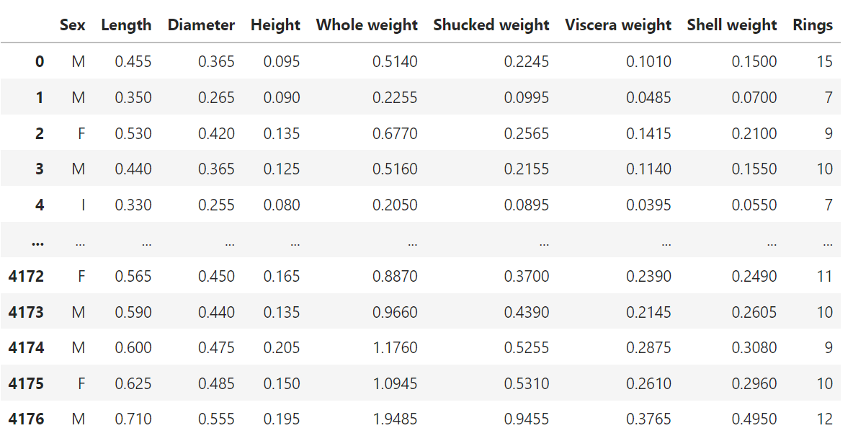

Adding 1.5 to the Rings value for getting Age.

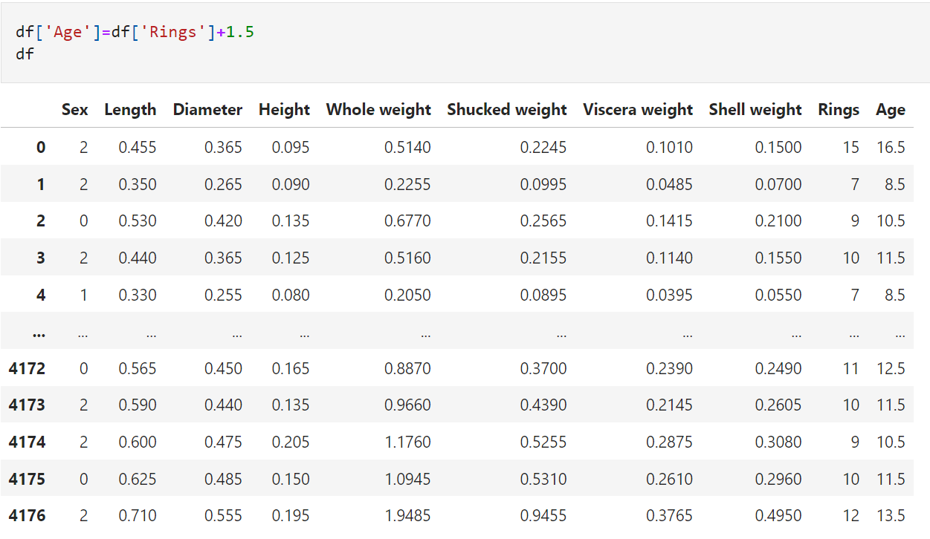



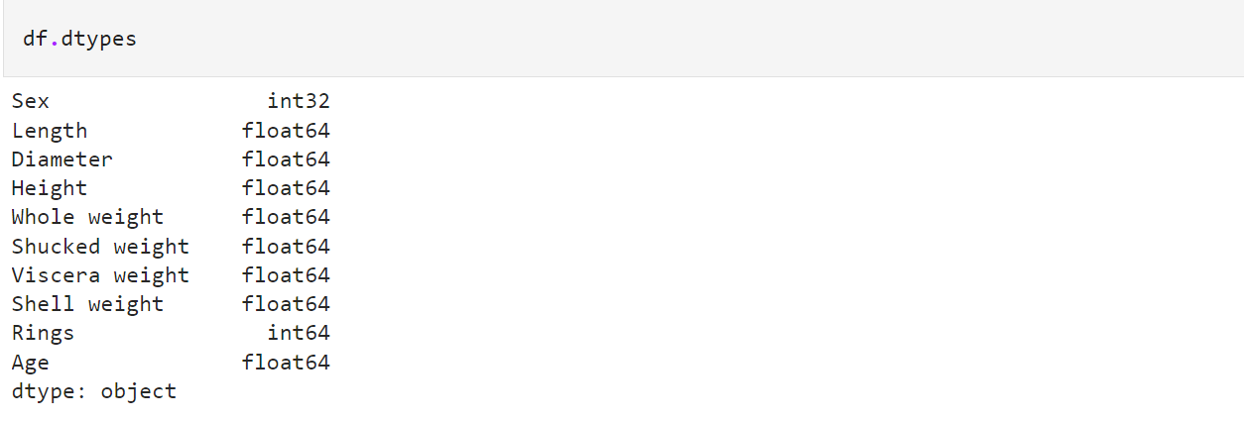

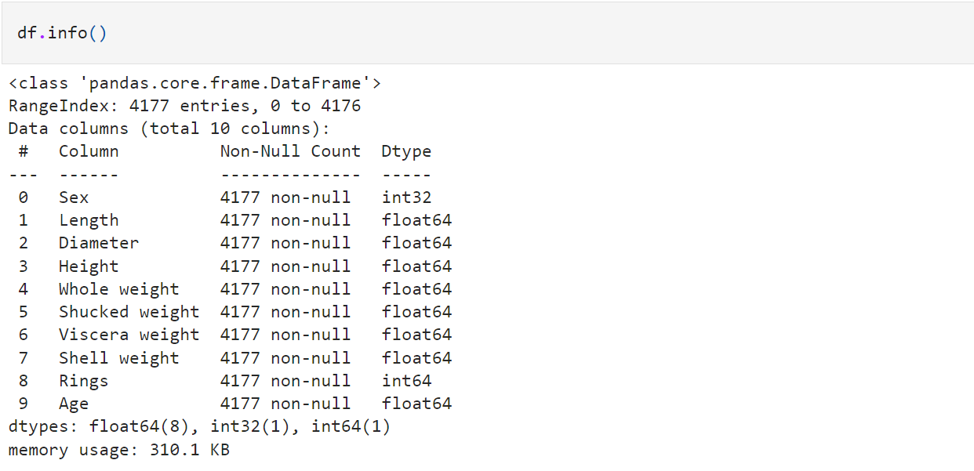

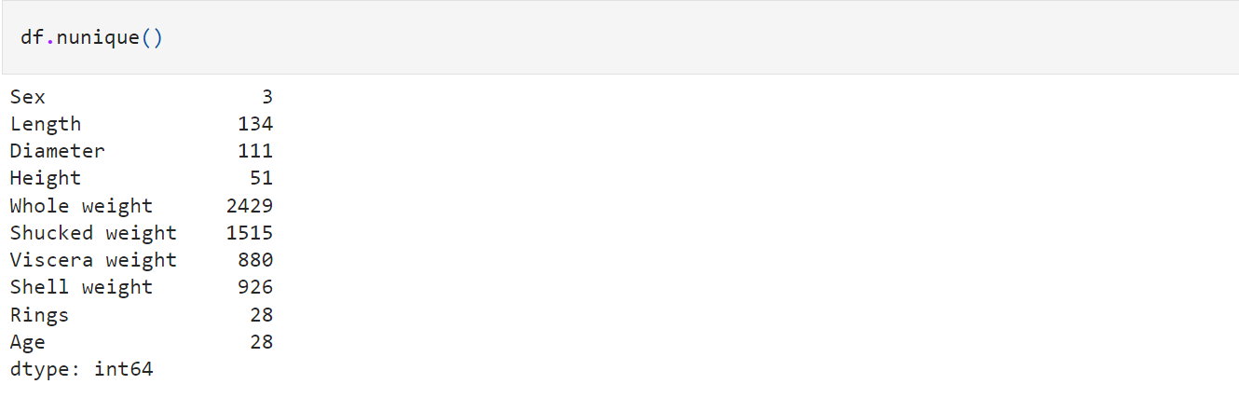

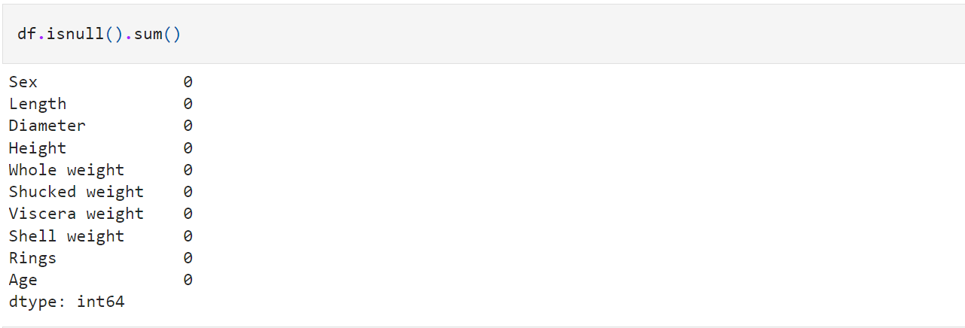

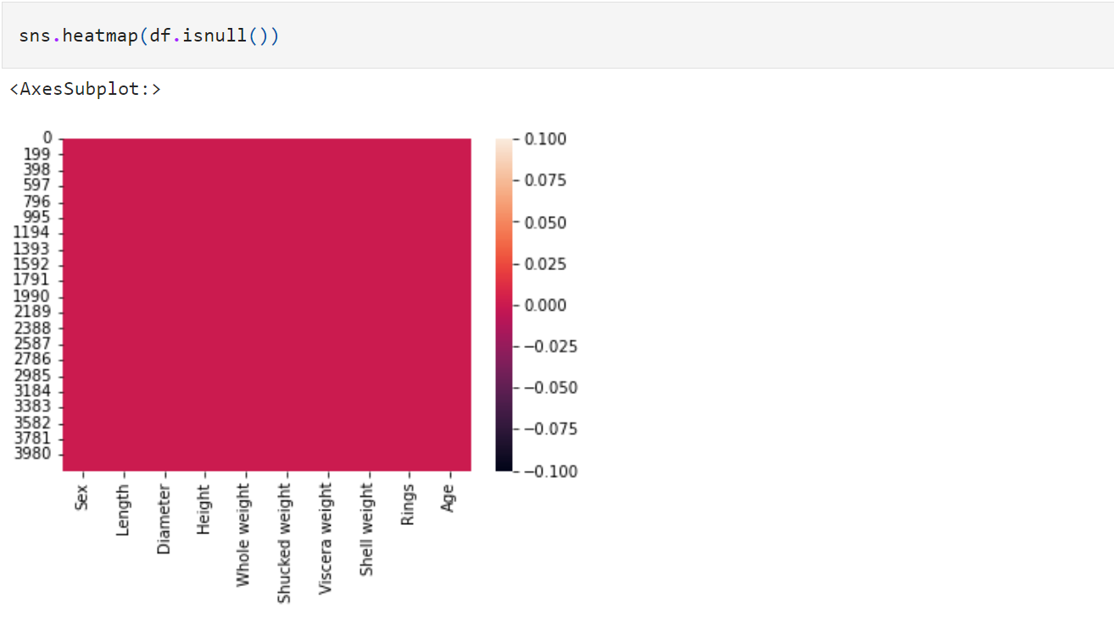

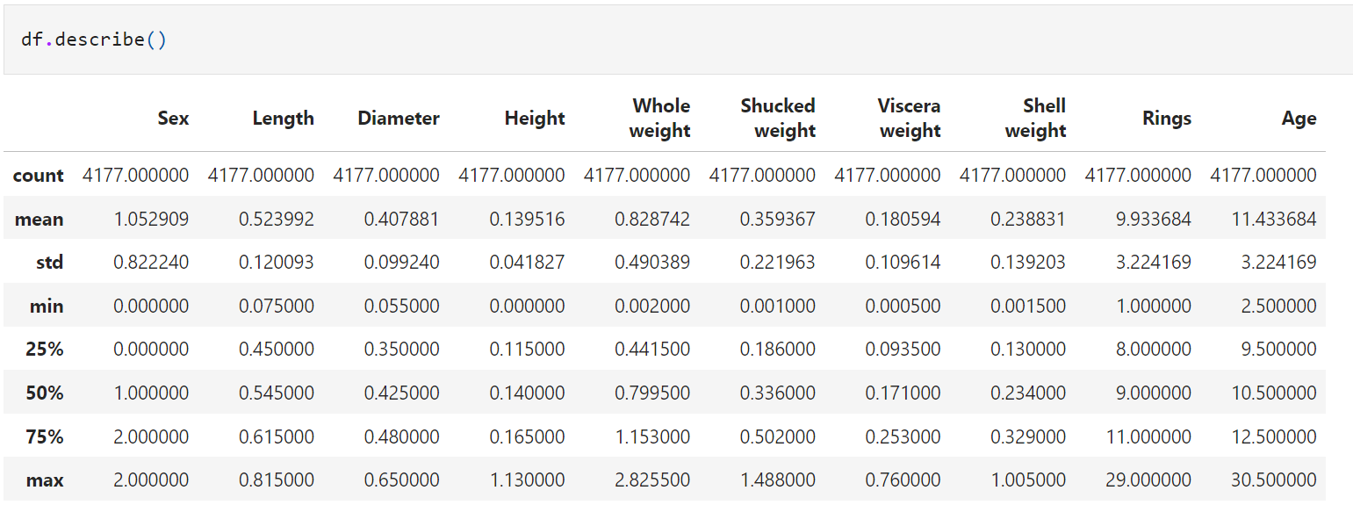

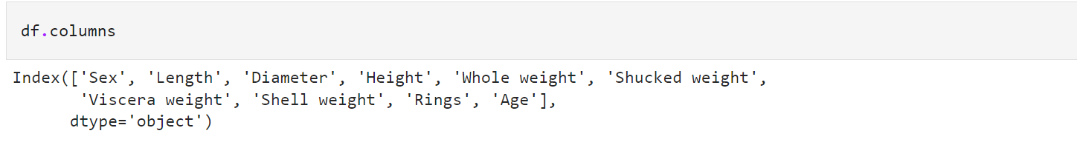

**Encoding:**



 